Natural Language Processing-Based Chatbot Application for E-learning General Inquiries using English and Filipino Corpus

## 1.3 Objectives

**1.3.1 General Objective**

The General Objective of this study is to develop a Natural Language Processing-Based Chatbot Application for E-learning General Inquiries using English corpus only for spoken words and Filipino & English Corpus for typewritten text thru chat.

* + 1. **Specific Objective**
* To develop the English Speech Corpus for spoken words and Filipino & English corpora for typewritten texts for the purpose of designing the chatbot application for E-learning general inquiries
* To develop the natural language processing algorithms for the chatbot application such as speech recognition, tokenization, lemmatization, named entity identification and intent classification
* To develop a working prototype of the chatbot ported in a PC-based graphical user interface application that integrates the corpora, natural language processing and database of chatbot response.
* To evaluate the performance of the system in terms of accuracy of English-spoken word to text conversion, slangs, typos, and misspellings to text conversion and confusion matrix for intent classification and achieved at least 80%.

## 3.2 Block Diagram

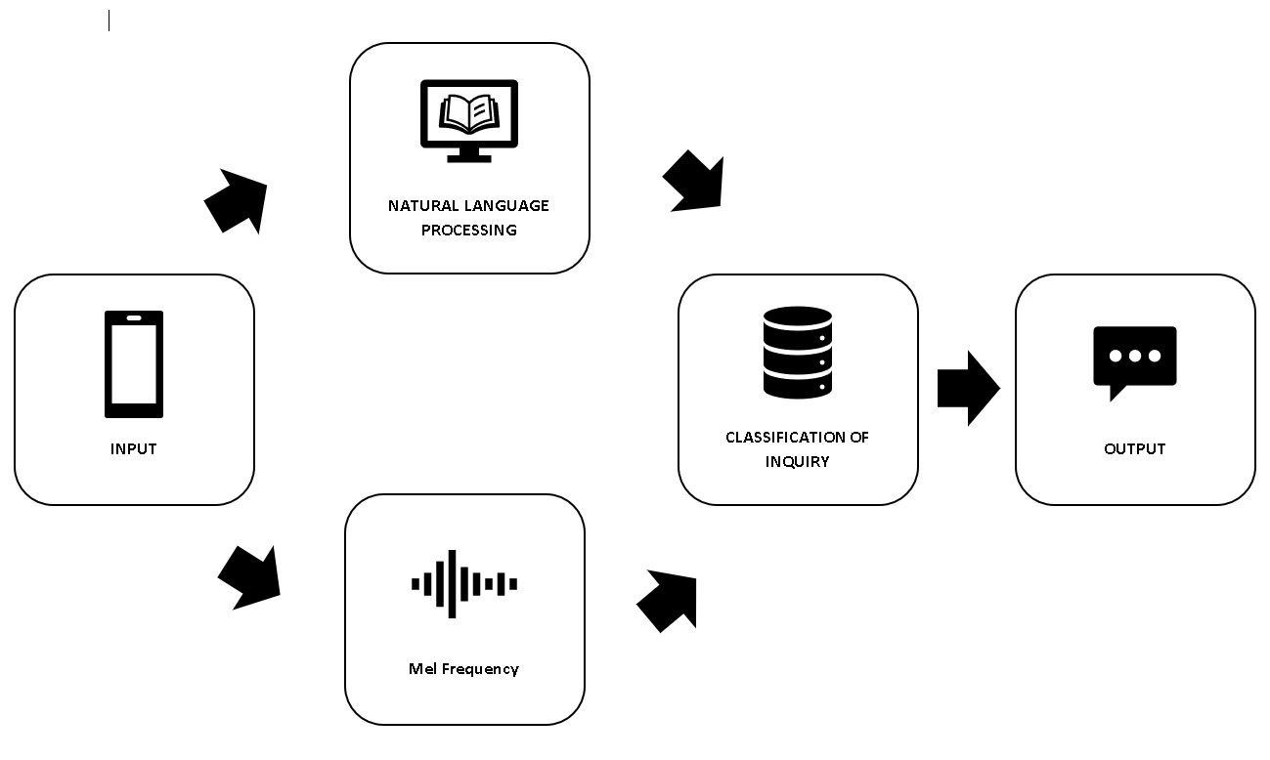

**Figure 10. General Framework Block Diagram**

The input text or speech will either undergo natural language processing for textual input or Mel-frequency cepstral coefficients for speech input to process the input data, and be classified with labels or tags namely Enrollment Steps, Miles Components, Tuition Inquiry, ECE/EE offerings, Locations, and Others which are shown at Table 6.

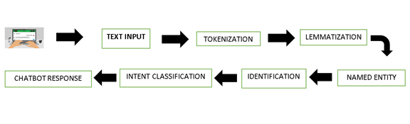

**Figure 11. System Block Diagram**

Figure represents the proposed block diagram for the chatbot. The input would be first process whether it is an audio or text and converts the text input sentence from the user is first segmented between words through the Tokenization. Wherein it will separate a text input sentence into smaller units like tokens so that it can proceed to Lemmatization. After the sentence separated in smaller unit of token the chatbot will lemmatize then strip off unnecessary words called stop words that does not change the thought of the overall meaning of the sentence through the process. The output that has been lemmatized is then classified into the predetermined classification these are Consultation, ECE/EE offerings, Enrollment Steps, Miles Components, and Tuition Inquiry of what class the word belongs to by the Named Entity Identification. The output is then given specified responses to the intent that are under the Intent Classification then converts the data into a vector and then it is trained through a Neural Network wherein the machine will be able to output a response to the input. The chatbot will process the Identification to the pre-determined category a will make a response based on the data it processes to make an accurate response to the user’s inquiry.

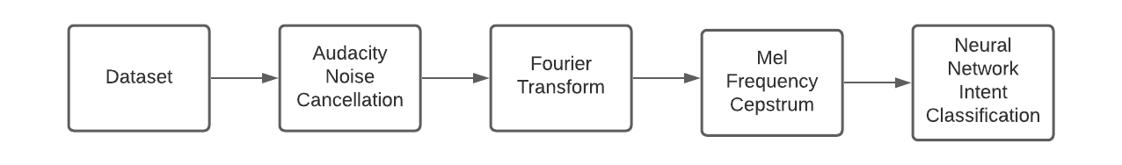

**Figure 12. Block Diagram for Speech Recognition**

A speech dataset corpus will first be pre-processed through the removal of the background noise which can be done through audacity the output will then go through Fourier Transforms to turn the audio waveform into the frequency domain which can be put into a feature extraction process of the Mel Frequency Cepstrum where in the output will be in the form of vectors which can then be appended with intents which will function as the input for the a Neural Network for Intent Classification purposes

### 3.1.2 Flow of block diagram

Here is what happens:

1. Login User/Password
2. User enter text/voice to the chatbox to tokenize the query
3. Data based tries to recognize the intent input query
4. Chatbot will response based on the query
5. User will provide a feedback

## 3.3    System Flowchart

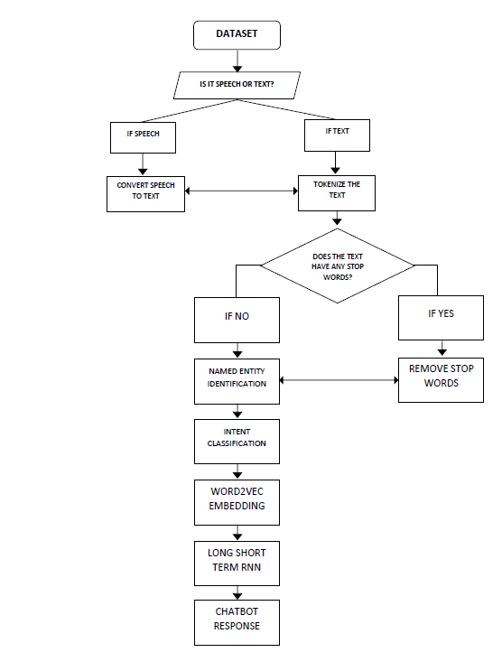

**Figure 13. System Flowchart**

In the proposed system flowchart for the chatbot when it receives the input in the form of text or audio the dataset would be then be analyzed. If the dataset is set to be text it will be tokenized immediately while if the dataset is in audio as will be explained in a separate flowchart wherein discussing about the text extraction in audio.

On the other hand, if input is already in textual form, it will go straight to the Lemmatization. If the input do not have any stop words or words that does not recognize by the chatbot then skips the process to the Named Entity Identification wherein the chatbot will identify and categorize individual words regarding its type such as location, name, or time. After the Named Entity Identification, it will then go to the Intent Classification, this is where the students query will be processed to find and classify named entities existing in the given text into pre-defined categories which will be divided into five named by Consultation, ECE/EE offerings, Enrollment Steps, Miles Components, and Tuition Inquiry, and then the words will then be converted into vector form through the Word2Vec embedding before ultimately put into an LSTM RNN which will be able to predict the proper response after training.



**Figure 14. Speech Recognition System Flowchart**

The figure below shows the system flowchart for the speech recognition. The program utilizes the Mel-Frequency ceptstrum(MFCC) to convert the audio signal into a matrix of vectors in order for it to undergo the Natural Language Processing. MFCC accepts signals in the frequency domain which means when it starts and the signal flows if it is in the time domain it is first converted into the frequency domain using the Fast Fourier Transform if the input signal is already in the frequency domain then it goes to the next step which is Short Term Fourier Transform.The output is then converted into an array containing the features of the signal through the Mel-Frequency ceptstrum(MFCC). the aggregate of all these features in a matrix form would be the classifier for the system. labels will then be appended to the vectors in the classifier, and the vector matrix and its labels will function as the independent and dependent variables for the Feed Forward Neural Network that uses the Adaptive Moment Estimation as the optimizer and the Cross Entropy as the loss function

## 3.4   Proposed System

The Model to be used to predict proper response to a user is a Long Short-Term Memory Recurrent Neural Network. The Dataset Corpus comprises both Filipino and English language that can accept 10 Queries. The word embedding to be used is the Word2Vec Continuous Bag of Words algorithm with 3 window sizes making the input shape for the LSTM Neural network 10 by 3.

The Dataset Corpus comprising both Filipino and English language will first be processed into the Natural Language Processing techniques wherein it is first fed into a Tokenizer which will segment each individual word apart which will then reduce each individual word into its root word called Lemmatization. It is then stripped of unnecessary words called stop words which are words that do not change the thought of the overall meaning of the sentence. The output is then put into a Named Entity Identification wherein the words are classified between different groups of tags. the output is then given its intent before having its word converted into vector form through Word2Vec algorithm wherein each word is converted into its specified One Hot Vector, the sentences are then each grouped by the chosen 3 word window size where in the middle word is used as the unknown or the dependent variable while the 2 outer words are used as the independent variable for the Word Embedding Feed Forward Neural Network with only 1 hidden layer with the same size as the chosen window size of 3. The Word Embedding Neural Network will then adjust the weights accordingly to get the correct center word from the given outer words which would make the words commonly used together have their weights close in value making them associated with each other. The output of the Word Embedding is fed into the LSTM Neural Network Model which will be trained using the Filipino and English language corpus that has a response built in for each intent. The LSTM Neural Network will use the Adaptive Moment Estimation (AdaMs) while the Cross Entropy would be used for the Loss Function. After the LSTM Neural Network is trained it will be able to output a response from the given user input.

#### Hardware System

**Ideal Graphic User Interface Logo**

**Natural Language Processing Chatbot Application for E-learning General Inquiries using English and Filipino Corpus**

**CPU**

In machine learning the dataset training is the most process intensive part, and according to the product engineering and semiconductor firm Einfochips Arrow Company []. An i7-7500 is enough to train 115 samples in under a second even without any necessary GPU. The proposed chatbot only has 106 dataset samples which means an i7-7500 CPU is more than adequate for the job.

.

**GPU**

According to the article made by Tim Dettemers from the University of Washington a GPU that possesses a Tensor Core will reduce the cycles needed for matrix multiplication and addition operations by 16 times as shown when a 32 x 32 matrix was reduced from 128 cycles into 8 cycles. The tensor cores help the machine learning process by transferring data from the shared memory into the tensor core which means that having a tensor core with higher memory bandwidth will be ideal. Between the 3 types of tensor cores that was presented namely Volta, Turing, and Ampere we can see that the Ampere type tensor core has the highest shared memory size while Turing comes close behind. For machine learning application a GPU that has an Ampere or Turing type tensor core with as much bandwidth as possible is the most ideal GPU, and that is the 3080 TI it was able to run a batch size of 462 samples in under a second while the proposed chatbot only possess 106 dataset sample in its entirety which means a 3080 is more than capable of training, but with its prize it's not as cost efficient. The RTX 2080 only has 448 Gb/s memory bandwidth compared to 3080’s 760 GB/s memory bandwidth, but the RTX 2080 possesses more tensor cores at 368 vs 272 of the RTX 3080 albeit they’re only Turing cores compared to RTX 3080’s Ampere cores. The RTX 3080 is indeed better as it was is able to train a batch size of 462 samples in a second while the RTX 2080 can only do 329, but with the proposed chatbot’s only 106 dataset samples the RTX 2080’s 329 batch size per second is more than enough to train the entire neural network.[]

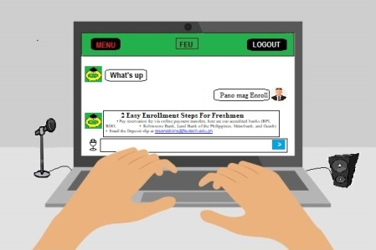  
Our proposed project have a text and speech processing option. If the input of the user is text, the neural network is the one responsible for responding to the user’s question. The neural network is a set of algorithms that takes the input and apply each steps of the algorithm to the information to generate an output. [2]If the input of the user is speech, the speech recognition is the one responsible for responding to the user’s question. The speech recognition does is to breaks down the audio into individual sounds then it will converts these sounds into a digital format and will use algorithms and models to find the most probable word or output fit in that language.

#### Software System

**Tensorflow**

Tensorflow is an end-to-end open source machine learning platform developed by Google. The software handles multidimensional arrays, and is able to perform computation on them making it suitable for Neural Network applications where in the connection between nodes in a neural network are made up of multidimensional arrays. Tensorflow’s wide range of library suited for various types of Neural Network applications makes it the best option for machine learning projects such as chatbots.

**Jupyter Notebook**

Project Jupyter notebook is a web based program that allows you to set codes and input data in the set program. Jupyter notebook is very convenient as it is an open source application and free to encode any information that matches our project.[]

**Audacity**

Audacity is an open source audio editor and recorder that is also capable of converting MP3 files into WAV format which is the format that is needed to be used as input for the audio side of the chatbot.

**Software Algorithm**

**NLP**

**Tokenization, and Removing stopwords**

def remove_stop_words(corpus):

stop_words = ['is', 'the', 'a', 'can', 'I', 'po', 'ba', 'ko']

results = []

for text in corpus:tmp=text.split(' ')

for useless in useless:

if useless in tmp:

tmp.remove(stop_word)

results.append(" ".join(tmp))

return results

corpus = remove_stop_words(corpus)

words = []

for text in corpus: for word in text.split(' '): words.append(word)words = set(words)

word2int = {}

for i,word in enumerate(words):

word2int[word] = I

sentences = []

for sentence in corpus:

sentences.append(sentence.split())

WINDOW_SIZE = 3

data = []

for sentence in sentences:

for idx, word in enumerate(sentence):

for neighbor in sentence[max(idx - WINDOW_SIZE, 0) : min(idx + WINDOW_SIZE, len(sentence)) + 1] :

if neighbor != word:

data.append([word, neighbor])

**Intent classification Word2Vec[39]**

import pandas as pd

import tensorflow as tf

import numpy as np

for text in corpus:

df = pd.DataFrame(data, columns = ['input', 'label'])

Word2int

ONE_HOT_DIM = len(words)

def to_one_hot_encoding(data_point_index):

one_hot_encoding = np.zeros(ONE_HOT_DIM)

one_hot_encodingdata_point_index] = 1

return one_hot_encoding

X = []

Y = []

for x, y in zip(df['input'], df['label']):

X.append(to_one_hot_encoding(word2int[ x ]))

Y.append(to_one_hot_encoding(word2int[ y ]))

X_train = np.asarray(X)

Y_train = np.asarray(Y)

x = tf.placeholder(tf.float32, shape=(None, ONE_HOT_DIM))

y_label = tf.placeholder(tf.float32, shape=(None, ONE_HOT_DIM))

EMBEDDING_DIM = 2

W1 = tf.Variable(tf.random_normal([ONE_HOT_DIM, EMBEDDING_DIM]))

b1 = tf.Variable(tf.random_normal([1]))

hidden_layer = tf.add(tf.matmul(x,W1), b1)

W2 = tf.Variable(tf.random_normal([EMBEDDING_DIM, ONE_HOT_DIM]))

b2 = tf.Variable(tf.random_normal([1]))

prediction = tf.nn.softmax(tf.add( tf.matmul(hidden_layer, W2), b2))

loss = tf.reduce_mean(-tf.reduce_sum(y_label * tf.log(prediction), axis=[1]))

train_op = tf.train.GradientDescentOptimizer(0.05).minimize(loss)

sess = tf.Session()

init = tf.global_variables_initializer()

sess.run(init)

iteration = 20000

for i in range(iteration):

sess.run(train_op, feed_dict={x: X_train, y_label: Y_train})

if i % 3000 == 0:

print('iteration '+str(i)+' loss is : ', sess.run(loss, feed_dict={x: X_train, y_label: Y_train}))

vectors = sess.run(W1 + b1)print(vectors)

For the tokenization, and removal of stop words process of the NLP an array containing the individual stop words desired to be removed which are comprised of is, the, a, can, I, po, ba, ko... are first created. Then we use python’s split command to segment the uploaded data set of text which will segment the the entire corpus into individual words, and then saved into the variable tmp. A for loop is then used to iterate, and use the conditional statement if the useless words are in the segmented dataset at tmp then we use python’s .remove function to remove the words in the tokenized dataset containing the stop_word array that contains the words to be removed which are namely is, the, a, can, I, po, ba, ko.

We now create a new variable word and iterate it over the tokenized word, and then put it into an empty array called words through the python’s append function the result will be individual sentences grouped together that are all segmented word for word then we utilize python’s set command to remove recurring words, and then we use word2int and int2word to set the words with integer values or vice versa, and giving the converted values a variable representation.

For the intent classification we first use pandas’ dataframe function and create 2 dataframes “input” and “labels” the input will be words we’re going to use and the label will be the corresponding intents for that specific input we then utilize python’s one hot encoding with the dimension given by the len function of python to get the length of the words to vectorize the words into distinct values, and then we create an array to store them in. We then use pandas library’s zip function to attach the one hot encoding vector with the input and labels, so now we have done word2vec which vectorized our inputs, and labels.

We then now set the 2 one hot encoding vector into the training variables for the neural network. We use W1 and b1 a the input layer, and is connected into a single hidden layer which is connected into the output layer comprising W2 and b2, and we’re using an activation function of softmax. The loss function is done using the reduce_mean which simply calculates the mean in the tensor, and then uses the Gradient Descent as the optimizer with a learning rate of 0.05. the trained model will now be able to associate words with the specified label provided.

### 3.4.1 Chatbot and User Conversation Script:

**Get started:**

Chatbot:  What’s up

User: What time can i consult with Engineer Juan Dela Cruz

Chatbot**:** Here's the list of his consultation hours

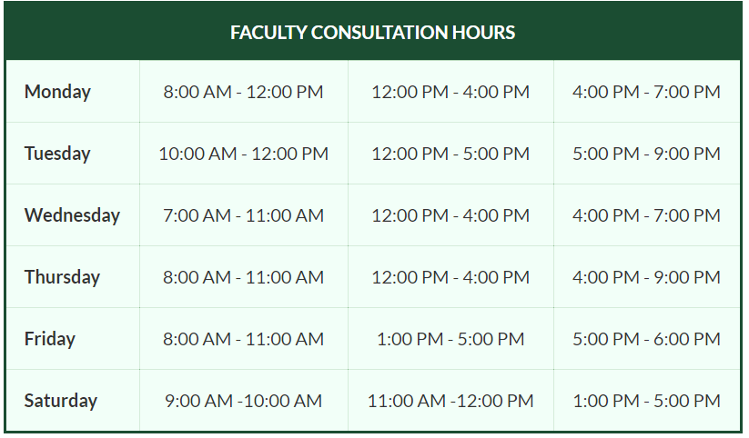

[**https://meet.google.com/vdr-repu-zjh?pli=1&authuser=1**](https://meet.google.com/vdr-repu-zjh?pli=1&authuser=1)

**JuanDelaCruz@gmail.com**

Users will be directed to the link, Email and schedule provided by the chatbot

**Get started:**

Chatbot: What’s up

User: pano mag enroll

Chatbot : **FEU - Institute of Technology Registration Directory**

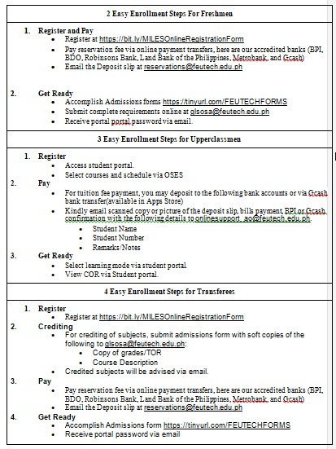

Chatbot will reply the Listed above the procedures on how to enroll in FEU Institute of Technology Freshmen, Upperclassmen and Transferees.

### 3.4.2 Graphic User Interface Platform Chatbot

|  |  |
| --- | --- |
| (a) | (b) |
| (c) | **(d)** |
| (e) | **(f)** |

**Figure 15. GUI of the chatbot**

Now that we have a common script with the User and chatbot. These are the common problems of students when looking for the assistance. It shows how easily to access the information between the users.

## 3.5 Testing Procedure

1. Testing the Entity
2. To test the Classification of Entity a sample of 22 trials calculated at part 3.5.4 is done where in each trial an input entity is taken with the machine’s own prediction of what type of Entity is produced if the Machine Entity Classification corresponds with the True Entity Classification, then the trial is tagged as 1 if not then its tagged as 0. the result is tallied in a Confusion Matrix where in the Total number of 1s are summed and then divided with the total number of trials i.e. 22 trials. If the output is equal to 80% stated from the objectives then the test is passed.
3. Testing the Classification of Intent
4. To test the Classification of Intent a sample of 22 trials calculated at part 3.5.4 is done where in each trial an input Intent is taken with the machine’s own prediction of what type of Intent is produced if the Machine Intent Classification corresponds with the True Intent Classification, then the trial is tagged as 1 if not then its tagged as 0. the result is tallied in a Confusion Matrix where in the Total number of 1s are summed and then divided with the total number of trials i.e. 22 trials. If the output is equal to 80% stated from the objectives then the test is passed.

**Table 3. NLP Task**

**A) Named Entity Recognition**

An entity is a key element in a text that will provide specific information that would vary the thought of the text, the entities will be handpicked in accordance with the NLP task it’s doing, and in the proposed chatbot it would fall under the classification of Location, Name and Time and the specific Entities will be specific words under these classifications. A few examples of the handpicked Input Entities for the testing phase are:

* Library
* EEE department
* Registrar
* Sir Poch
* Today
* Tomorrow

The accuracy test will determine whether the 22 handpicked entities are tagged with the right classification of Entity.

**Table 5. Classification of Entity**

|  |  |
| --- | --- |
| **Class no.** | **Classification of Entity** |
| **1** | Location |
| **2** | Name |
| **3** | Time |

**Table 6. Named Entity Recognition**

|  |  |  |  |
| --- | --- | --- | --- |
|  | Input Entity | Machine Entity Classification | Correctness of conversion |
| 1 | Sample typewritten Entity 1 | Machine Entity Classification 1 | Identified by 1 or 0 |
| 2 | Sample typewritten Entity d 2 | Machine Entity Classification 2 | Identified by 1 or 0 |
| 3 | Sample typewritten Entity 3 | Machine Entity Classification 3 | Identified by 1 or 0 |
| 4 | Sample typewritten Entity 4 | Machine Entity Classification 4 | Identified by 1 or 0 |
| 5 | Sample typewritten Entity 5 | Machine Entity Classification 5 | Identified by 1 or 0 |
| . | . | . | . |
| 22 | Sample typewritten Entity 22 | Machine Entity Classification 22 | Identified by 1 or 0 |

**B) Intent Classification**

Intents are the purpose or what the person providing the input is trying to say. They are the users intentions behind the input text they’ve provided. The typewritten and spoken questions will be handpicked in accordance with the NLP task it’s doing, and in the proposed chatbot it would fall under the classifications of Consultation, ECE/EE Offerings, Enrollment Steps, Miles Components, Tuition Inquiry, Location, and others. The specific Intents will be sample sentences under these classifications.

A few examples of the Classification of Intents Questions are:

* Where is the Library?
* Kelan po Enrollment?
* Where do I pay the tuition fee?,
* Is Sir Poch Available right now?

The accuracy test will determine whether the 22 handpicked Questions are tagged with the right classification of Intents

**Table 7. Classification of Intents**

|  |  |  |  |  |  |
| --- | --- | --- | --- | --- | --- |
| **Class no.** | **Classification of intents** | **Class no.** | **Classification of intents** | **Class no.** | **Classification of intents** |
| **1** | Consultation | 4 | Miles Components | 7 | Others |
| **2** | ECE/EE offerings | 5 | Tuition Inquiry |
| **3** | Enrollment Steps | 6 | Location |

|  |  |  |  |  |
| --- | --- | --- | --- | --- |
|  | Type written chat or spoken word question | Predicted | Expected | Correctness of classification |
| 1 | Sample Typewritten word | Class No. | Class No. | Identified by 1 or 0 |
| 2 | Sample Spoken word | Class No. | Class No. | Identified by 1 or 0 |
| 3 | Sample Typewritten word | Class No. | Class No. | Identified by 1 or 0 |
| 4 | Sample Spoken word | Class No. | Class No. | Identified by 1 or 0 |
| 5 | Sample Spoken word | Class No. | Class No. | Identified by 1 or 0 |
| . | .. | .. | .. | .. |
| 22 | Sample Spoken word | Class No. | Class No. | Identified by 1 or 0 |

**Table 8. Conversion of typewritten word to text**

|  |  |  |  |  |
| --- | --- | --- | --- | --- |
|  | Speech Input | Predicted | Expected | Correctness of classification |
| 1 | Speech Input word 1 | Class No. | Class No. | Identified by 1 or 0 |
| 2 | Speech Input word 2 | Class No. | Class No. | Identified by 1 or 0 |
| 3 | Speech Input word 3 | Class No. | Class No. | Identified by 1 or 0 |
| 4 | Speech Input word 4 | Class No. | Class No. | Identified by 1 or 0 |
| 5 | Speech Input word 5 | Class No. | Class No. | Identified by 1 or 0 |
| . | . | . | . | . |
| 22 | Speech Input word 22 | Class No. | Class No. | Identified by 1 or 0 |

**Table 9. Speech Input**

For the classification of intent, the software gathers the different input like the speech and typewritten word. The predicted class number of the tables on which the chatbot categorized the input will be identifies based on seven classifications to gather the accuracy of the chatbot we also shows what should be the expected class to at the inputs by knowing the difference of the predicted and expected we measure the correctness of classification on which the data use will be classified in the confusion matrix.

**Table 107. Confusion Matrix**

|  |  |  |  |  |  |  |  |  |
| --- | --- | --- | --- | --- | --- | --- | --- | --- |
|  | Consultation | EEE Course offerings | Enrollment Step | Miles Component | Tuition Inquiry | Location | Others | Total Classification |
| Consultation |  |  |  |  |  |  |  |  |
| EEE Course offerings |  |  |  |  |  |  |  |  |
| Enrollment Step |  |  |  |  |  |  |  |  |
| Miles Component |  |  |  |  |  |  |  |  |
| Tuition Inquiry |  |  |  |  |  |  |  |  |
| Location |  |  |  |  |  |  |  |  |
| Others |  |  |  |  |  |  |  |  |
| Total Classification |  |  |  |  |  |  |  |  |

Legend:

|  |  |
| --- | --- |
| Incorrect Prediction |  |
| Correct Prediction |  |

In this project, we used confusion matrix which is useful in machine learning method to match the possible questions of students to the nearest possible correct answers. The shaded part corresponds to correct prediction while the unshaded part corresponds to incorrect prediction. We used seven intent or categories that we classify as the most common question or queries that a students may ask in our chatbot.

8.1. Confusion Matrix Accuracy

The classification model statistical measures we can derive. This is a general examine of the model fulfillment. To get the accuracy in the Confusion Matrix we sum up the total number of 1s which illustrate the True Positive Value and the total number of 0s which illustrate the True Negative Value the sum is divided by the total number of Trials represented by 22 shown by the 3.5.4

TP = True Positive

TN = True Negative

TP + TN / Total No. of Records = Total Accuracy

### 3.5.2. Questions and Answers

**Table 11. Questions and Chatbot Response**

**ECE/EE Offerings**

**English Queries**

|  |  |  |
| --- | --- | --- |
| QUESTION | IDENTIFICATION | CHATBOT RESPONSE |
| What is the ECE/EE does subject offers | Year Level or EE/ECE | Subject and Course |

**Filipino Queries**

|  |  |  |
| --- | --- | --- |
| QUESTION | IDENTIFICATION | CHATBOT RESPONSE |
| Ano yung mga subjects na binibigay ng ECE/EE | Year Level or EE/ECE | Subject and Course |

**Mixed English and Filipino Queries**

|  |  |  |
| --- | --- | --- |
| QUESTION | IDENTIFICATION | CHATBOT RESPONSE |
| What is the ECE/EE does subject offers / Ano yung mga subjects na binibigay ng ECE/EE | Year Level or EE/ECE | Subject and Course |

**Consultation**

**English Queries**

|  |  |  |
| --- | --- | --- |
| QUESTION | IDENTIFICATION | CHATBOT RESPONSE |
| When | Time | Time |

**Filipino Queries**

|  |  |  |
| --- | --- | --- |
| QUESTION | IDENTIFICATION | CHATBOT RESPONSE |
| Kailan | Time | Time |

**Mixed English and Filipino Queries**

|  |  |  |
| --- | --- | --- |
| QUESTION | IDENTIFICATION | CHATBOT RESPONSE |
| When/Kailan | Time | Time |

**MILES Component**

**English Queries**

|  |  |  |
| --- | --- | --- |
| QUESTION | IDENTIFICATION | CHATBOT RESPONSE |
| What is the FORMATIVE | MILES | MILES |

**Filipino Queries**

|  |  |  |
| --- | --- | --- |
| QUESTION | IDENTIFICATION | CHATBOT RESPONSE |
| Ano ang FORMATIVE | MILES | MILES |

**Mixed English and Filipino Queries**

|  |  |  |
| --- | --- | --- |
| QUESTION | IDENTIFICATION | CHATBOT RESPONSE |
| What is the FORMATIVE/ Ano ang FORMATIVE | MILES | MILES |

**Tuition Inquiry**

**English Queries**

|  |  |  |
| --- | --- | --- |
| QUESTION | IDENTIFICATION | CHATBOT RESPONSE |
| How to pay in online bank | Tuition Inquiry | Payment Options |

**Filipino Queries**

|  |  |  |
| --- | --- | --- |
| QUESTION | IDENTIFICATION | CHATBOT RESPONSE |
| Paano magbayad ng online | Tuition Inquiry | Payment Options |

**Mixed English and Filipino Queries**

|  |  |  |
| --- | --- | --- |
| QUESTION | IDENTIFICATION | CHATBOT RESPONSE |
| How to pay in online bank/ Paano magbayad ng online | Tuition Inquiry | Payment Options |

**Enrollment Steps**

**English Queries**

|  |  |  |
| --- | --- | --- |
| QUESTION | IDENTIFICATION | CHATBOT RESPONSE |
| How to enroll in subject | Enrollment | Enrollment Process |
| What is the deadline of registration | Registration | Registration Process |

**Filipino Queries**

|  |  |  |
| --- | --- | --- |
| QUESTION | IDENTIFICATION | CHATBOT RESPONSE |
| Paano magenroll sa | Enrollment | Enrollment Process |
| Kailan ang huling araw ng registration | Registration | Registration Process |

**Mixed English and Filipino Queries**

|  |  |  |
| --- | --- | --- |
| QUESTION | IDENTIFICATION | CHATBOT RESPONSE |
| Paano magenroll sa subject | Enrollment | Enrollment Process |
| Kailan ang last day ng registration | Registration | Registration Process |

**Others**

**English Queries**

|  |  |  |
| --- | --- | --- |
| QUESTION | IDENTIFICATION | CHATBOT RESPONSE |
| Where is my room | Others | Answers the question with unrelated response |
| What is my subject | Others | Answers the question with unrelated response |

**Filipino Queries**

|  |  |  |
| --- | --- | --- |
| QUESTION | IDENTIFICATION | CHATBOT RESPONSE |
| Saan ako ngayon | Others | Answers the question with unrelated response |
| Anong oras next class ko | Others | Answers the question with unrelated response |

**Mixed English and Filipino Queries**

|  |  |  |
| --- | --- | --- |
| QUESTION | IDENTIFICATION | CHATBOT RESPONSE |
| Saan ang room ko | Others | Answers the question with unrelated response |
| Ano ang next subject ko | Others | Answers the question with unrelated response |

### 3.5.3 List of information in FEU Institute of Technology

**FEU - Institute of Technology Payments’ Directory**

|  |  |
| --- | --- |
| **SERVICES** | **LINK/EMAIL/CONTACT** |
| **For admissions** | **info@feutech.edu.ph** |
| **For tuition fee and balance** | **onlinesupport_ao@feutech.edu.ph** |
| **For upperclassmen enrollment and scholarship** | **onlinesupport_ro@feutech.edu.ph** |
| **Please visit the link below for payment methods.** | [**https://www.feutech.edu.ph/admission/feu-tech-bank-details/**](https://l.facebook.com/l.php?u=https%3A%2F%2Fwww.feutech.edu.ph%2Fadmission%2Ffeu-tech-bank-details%2F%3Ffbclid%3DIwAR0hKd6qvi7AsAyG_AAKlp4MzBOmgMO9Uwqft6WAl2P-TAjvl7onX5Bx0Yg&h=AT2TUuQXqip-sP6PIU4cLyXnMq8hicl-_GNzuVKTxScrsqvrRSkiBDQO7Bb5eKmJyV9-tcUh1x2n8LpgXGyn6cfVcE-JXVBtuXYbaH98TmF9DIxbzLmOf5SbYtQ4eUR5W8itvA) |
| **Bank of the Philippine Islands - Morayta Branch**  -Online / Over the Counter : CASH Deposit Only  -For OLD and NEW Students | **-Account Name :** East Asia Computer Center Inc  **-Account No.:** 1581-00-2218 |
| **Bank of the Philippine Islands - Morayta Branch**  -Online / Over the Counter : CASH ONLY  -For OLD Students Only | **-Account Name :** FEU – East Asia Colleg**e**  **-Account No.:** 1581-00-1246 |
| **Robinsons Bank - Main Office Branch**  -Online / Over the Counter : CASH Deposit Only  -For OLD and NEW Students | **-Account Name :** East Asia Computer Center Inc  **-Account No.:** 1000-30-1000-17409 |
| **Land Bank of the Philippines - España Branch**  -Over the Counter : CASH Deposit Only  -For OLD and NEW Students | **-Account Name :** East Asia Computer Center Inc  **-Account No.:** 3721-0063-19 |
| **Banco De Oro - Recto Branch**  -Online / Over the Counter : CASH Deposit Only  -For OLD and NEW Students | **-Account Name :** East Asia Computer Center Inc  **-Account No.:** 0000-2000-7515 |
| **Metrobank - Morayta Branch**  -Online / Over the Counter : CASH Deposit Only  -For OLD and NEW Student**s** | **-Account Name :** East Asia Computer Center Inc  **-Account No.:** 184-7-18450897-0 |
| **GCASH Bank** | |
| **BPI** | **-Account Name:** FEU Institute of Technology  **-Account Number:** 1581002218 |
| **BDO** | **-Account Name:** FEU Institute of Technology  **-Account Number:** 000020007515 |
| **Metrobank** | **-Account Name:** FEU Institute of Technology  **-Account Number:** 1847184508970 |
| **Lankbank** | **-Account Name:** FEU Institute of Technology  **-Account Number:** 3721006319 |
| **Robinsons Bank** | **-Account Name:** FEU Institute of Technology  **-Account Number:** 100030100017409 |
| **Gcash Procedure**   * + **Log in**   + **Bank Transfer**   + **Choose Bank**   + **Fill out (Amount, Account Name, Account Number and Email Address)**   + **Send Money**   + **Review and Confirm** | |
|  |
|  |
|  |
|  |
|  |

**You can make your tuition payment thru the following bank.**

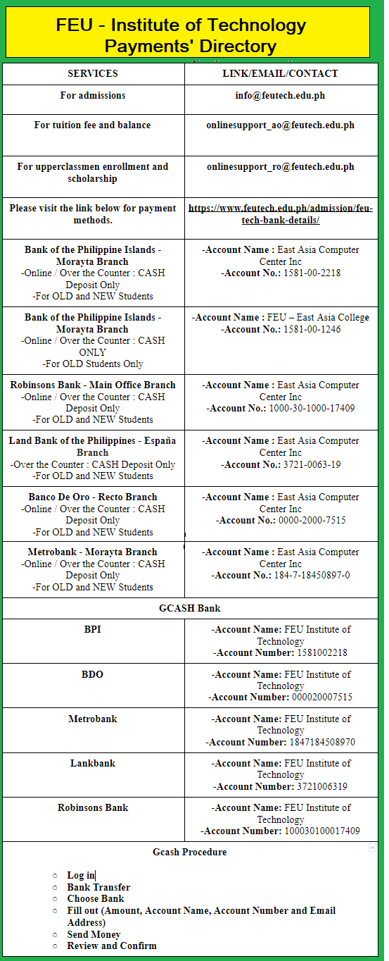

**FEU - Institute of Technology Floor Directory**

|  |  |
| --- | --- |
| **SERVICES** | **ROOM/FLOOR NO.** |
| **Discipline Office** | **F203** |
| **Health Services Unit (Medical and Dental** | **F412** |
| **Humanities, Social science and Communication (HSC)** | **F506** |
| **Cafeteria (Canteen)** | **8th Floor** |
| **Electrical,Electronic Engineering Dept. (EEE)** | **F911** |
| **Computer Engineering Dept. (CpE)** | **F1013** |
| **Math and Physical Science Dept. (MPS)** | **F1102** |
| **Mechanical Engineering  Dept. (ME)** | **F1104** |
| **Course Reservation (OSES)** | **F1203** |
| **Computer Services Office (CSO)** | **F1204** |
| **Library** | **14th Floor** |
| **Guidance and Counseling Unit/SSO** | **F1501** |
| **SSO Clients’ Waiting Area** | **F1502** |
| **IT/CS/BMA/EMC Dept.** | **F1504** |
| **Admission’s Office** | **F1506** |
| **Registrar’s Office** | **F1507** |
| **Cashiers** | **F1508** |
| **Balance Inquiry/Promissory Note Requests/Uniform Fitting** | **F1509** |
| **Industry-Academe Linkage, Alumni, and Placement (IALAP)** | **F1601** |
| **Civil Engineering Dept. (CE)** | **F1605** |
| **Information Desk** | **2nd Floor** |

**Provided in the image below is the floor directory of FEU Institute of Technology building.**

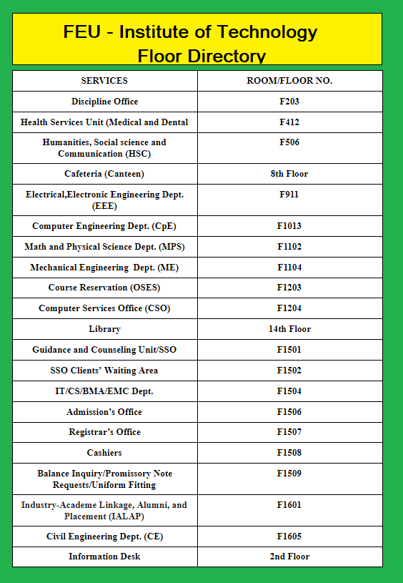

**FEU - Institute of Technology Registration Directory**

|  |
| --- |
| **2 Easy Enrollment Steps For Freshmen** |
| 1. **Register and Pay**  * Register at <https://bit.ly/MILESOnlineRegistrationForm> * Pay reservation fee via online payment transfers, here are our accredited banks (BPI, BDO, Robinsons Bank, Land Bank of the Philippines, Metrobank, and Gcash) * Email the Deposit slip at [reservations@feutech.edu.ph](mailto:reservations@feutech.edu.ph)  1. **Get Ready**  * Accomplish Admissions forms <https://tinyurl.com/FEUTECHFORMS> * Submit complete requirements online at [glsosa@feutech.edu.ph](mailto:glsosa@feutech.edu.ph) * Receive portal portal password via email. |
|  |
| **3 Easy Enrollment Steps for Upperclassmen** |  |
| 1. **Register**  * Access student portal. * Select courses and schedule via OSES  1. **Pay**  * For tuition fee payment, you may deposit to the following bank accounts or via Gcash bank transfer(available in Apps Store) * Kindly email scanned copy or picture of the deposit slip, bills payment, BPI or Gcash confirmation with the following details to [onlinesupport_ao@feutech.edu.ph](mailto:toonlinesupport_ao@feutech.edu.ph). * Student Name * Student Number * Remarks/Notes  1. **Get Ready**  * Select learning mode via student portal. * View COR via Student portal. |  |
| **4 Easy Enrollment Steps for Transferees** |  |
| 1. **Register**  * Register at <https://bit.ly/MILESOnlineRegistrationForm>  1. **Crediting**  * For crediting of subjects, submit admissions form with soft copies of the following to [glsosa@feutech.edu.ph](mailto:glsosa@feutech.edu.ph): * Copy of grades/TOR * Course Description * Credited subjects will be advised via email.  1. **Pay**  * Pay reservation fee via online payment transfers, here are our accredited banks (BPI, BDO, Robinsons Bank, Land Bank of the Philippines, Metrobank, and Gcash) * Email the Deposit slip at [reservations@feutech.edu.ph](mailto:reservations@feutech.edu.ph)  1. **Get Ready**  * Accomplish Admissions form <https://tinyurl.com/FEUTECHFORMS> * Receive portal password via email |  |

Listed above are the procedures on how to enroll in FEU Institute of Technology Freshmen, Upperclassmen and Transferees.

**FEU - Institute of Technology Professor Consultation, Cashier and Registrar Time Schedule**

|  |  |
| --- | --- |
| **Doc. Engr. Juan Dela Cruz Ph.D** | [**https://meet.google.com/vdr-repu-zjh?pli=1&authuser=1**](https://meet.google.com/vdr-repu-zjh?pli=1&authuser=1)  **JuanDelaCruz@gmail.com** |
| **Engineer. Pedro Magtapang, Ph.D** | [**https://meet.google.com/vdr-repu-zjh?pli=1&authuser=2**](https://meet.google.com/vdr-repu-zjh?pli=1&authuser=2)  **Enrg.PedroMagtapang01@gmail.com** |
| **Engineer. Maria Gonda** | [**https://meet.google.com/vdr-repu-zjh?pli=1&authuser=3**](https://meet.google.com/vdr-repu-zjh?pli=1&authuser=3)  **MariaG@gmail.com** |
| **Cashier** | **Monday - Saturday 08:00 - 15:00** |
| **Registrar Office** | **Monday - Saturday 08:00 - 15:00** |

The list of available time for the student to reach their preferred professor, virtual offices, Emails cashier and registrar office.

**MILES Components**

|  |  |
| --- | --- |
| **[MAIN]** | A PowerPoint presentation for the whole module including its subtopics (uploaded in Canvas in pdf format). |
| **[POWERPOINT]** | A PowerPoint presentation for the respective subtopic (uploaded in Canvas in pdf format).. |
| **[VIDEO]** | A recorded discussion for the respective subtopic |
| **[FORMATIVE]** | An unrecorded quiz-type assessment of the acquired knowledge for each subtopic/module |
| **[SUPPLEMENTARY]** | An additional material to strengthen your knowledge for each subtopic/module |
| **[CONSULTATION]** | An online-based meeting with your teacher. |
| **[GUIDE]** | A study guide/reviewer that you should read before taking the summative assessment. |
| **[PREPARATION]** | An activity (e.g., tutorial) to be conducted prior to taking the summative assessment |
| **[SUMMATIVE]** | A recorded assessment via a quiz-type, project-based, or, hands-on method at the end of each module |
| **[TECHNICAL]** | A recorded assessment via a hands-on or output-based activity |
| **[REVIEW]** | A link to a topic from your previous course  that you may use as a reviewer. |
| **[ADVANCED]** | A link to a topic from a future course  that you may use to advance your knowledge |
| **[FINAL]** | A recorded assessment via a quiz-type, project-based, or, hands-on method at the end of the course. |

These tags are preceded by M#S# which identifies the module number and subtopic number where a certain activity belongs. For example, an activity named "[M1S1-VIDEO] Introduction to Computing" means that this is a video recording of the topic "Introduction to Computing" which belongs to the first subtopic of Module 1.

**ECE/EE Course Offering**

|  |  |  |  |  |
| --- | --- | --- | --- | --- |
| ECE/EE Courses | Section | Remaining | Day | Time |
| ADVANCE DSP | 1-A | 45 | TBA | TBA |
| ADMATH | 1-A | 45 | TBA | TBA |
| BRDACOUSTIC | 1-A | 45 | TBA | TBA |
| BROADCST | 1-A | 45 | TBA | TBA |
| CIRCUITS1 | 1-A | 45 | TBA | TBA |
| CIRCUITS2 | 1-A | 45 | TBA | TBA |
| CIRCUITS3 | 1-A | 45 | TBA | TBA |
| CIRCUIT1LAB | 1-A | 45 | TBA | TBA |
| CIRCUIT2LAB | 1-A | 45 | TBA | TBA |
| CIRCUIT3LAB | 1-A | 45 | TBA | TBA |
| COMMS1 | 1-A | 45 | TBA | TBA |
| COMMS2 | 1-A | 45 | TBA | TBA |
| COMMS3 | 1-A | 45 | TBA | TBA |
| COMMS1LAB | 1-A | 45 | TBA | TBA |
| COMMS2LAB | 1-A | 45 | TBA | TBA |
| COMMS3LAB | 1-A | 45 | TBA | TBA |
| DCOM1 | 1-A | 45 | TBA | TBA |
| DCOM2 | 1-A | 45 | TBA | TBA |
| DCOM1LAB | 1-A | 45 | TBA | TBA |
| DCOM2LAB | 1-A | 45 | TBA | TBA |
| DIGICON | 1-A | 45 | TBA | TBA |
| DSPAPPS | 1-A | 45 | TBA | TBA |
| DSPLAB | 1-A | 45 | TBA | TBA |
| ECE101 | 1-A | 45 | TBA | TBA |
| ECEINTC1 | 1-A | 45 | TBA | TBA |
| ECEINTC2 | 1-A | 45 | TBA | TBA |
| ECEINTC3 | 1-A | 45 | TBA | TBA |
| ECEINTERN | 1-A | 45 | TBA | TBA |
| ECELAWCE | 1-A | 45 | TBA | TBA |
| ECELEMAGS | 1-A | 45 | TBA | TBA |
| ECEMICRO | 1-A | 45 | TBA | TBA |
| ECEMICRLAB | 1-A | 45 | TBA | TBA |
| ECENUME | 1-A | 45 | TBA | TBA |
| ECENUMELAB | 1-A | 45 | TBA | TBA |
| ECESEMF | 1-A | 45 | TBA | TBA |
| ECETECHNO | 1-A | 45 | TBA | TBA |
| EE101 | 1-B | 45 | TBA | TBA |
| EEINTC1 | 1-A | 45 | TBA | TBA |
| EEINTC2 | 1-A | 45 | TBA | TBA |
| EEINTC3 | 1-A | 45 | TBA | TBA |
| EEINTERN | 1-A | 45 | TBA | TBA |
| EEBASIC | 1-A | 45 | TBA | TBA |
| EECOMP | 1-A | 45 | TBA | TBA |
| EECOMPLAB | 1-A | 45 | TBA | TBA |
| EEINFOTEC | 1-A | 45 | TBA | TBA |
| EETECHNO | 1-A | 45 | TBA | TBA |
| EELAWS | 1-A | 45 | TBA | TBA |
| EEQUIPMT | 1-A | 45 | TBA | TBA |
| EESAFETY | 1-A | 45 | TBA | TBA |
| EESEMFIELD | 1-A | 45 | TBA | TBA |
| EGYCON | 1-A | 45 | TBA | TBA |
| EGYCONLAB | 1-A | 45 | TBA | TBA |
| EGYINSTRU | 1-A | 45 | TBA | TBA |
| EGYINSTRULAB | 1-A | 45 | TBA | TBA |
| EGYLOGIC | 1-A | 45 | TBA | TBA |
| EGYLOGICLAB | 1-A | 45 | TBA | TBA |
| EGYMICROPS | 1-A | 45 | TBA | TBA |
| EGYMICROPSL | 1-A | 45 | TBA | TBA |
| EGYPOWDPA | 1-A | 45 | TBA | TBA |
| EGYPOWSYS | 1-A | 45 | TBA | TBA |
| ELECS1 | 1-A | 45 | TBA | TBA |
| ELECS2 | 1-A | 45 | TBA | TBA |
| ELECS3 | 1-A | 45 | TBA | TBA |
| ELECS4 | 1-A | 45 | TBA | TBA |
| ELECS1LAB | 1-A | 45 | TBA | TBA |
| ELECS2LAB | 1-A | 45 | TBA | TBA |
| ELECS3LAB | 1-A | 45 | TBA | TBA |
| ELECS4LAB | 1-A | 45 | TBA | TBA |
| ELECTRANSDI | 1-A | 45 | TBA | TBA |
| ELECTRANSDILAB | 1-A | 45 | TBA | TBA |
| FEEDBACK | 1-A | 45 | TBA | TBA |
| FEEDBACK LAB | 1-A | 45 | TBA | TBA |
| LOGIC | 1-A | 45 | TBA | TBA |
| LOGICLAB | 1-A | 45 | TBA | TBA |
| ROBOTICS | 1-A | 45 | TBA | TBA |
| SAFETY | 1-A | 45 | TBA | TBA |
| POWSURGE | 1-A | 45 | TBA | TBA |
| SIGPRO | 1-A | 45 | TBA | TBA |
| TELECOM | 1-A | 45 | TBA | TBA |
| THESIS1 | 1-A | 45 | TBA | TBA |
| THESIS2 | 1-A | 45 | TBA | TBA |

Listed above are the courses offering that can enroll in EEE department at FEU Institute of Technology.

**Other Queries**

|  |  |
| --- | --- |
| **Other queries** | **Chatbot** |
| **papasa ba ko** | **For more information:**  **info@feutech.edu.ph** |
| **pano isolve to** |
| **ano ang resistor** |
| **May cisco 5 ba sa ECE** |
| **nanjan na si sir** |
| **ano ang topic ngayon** |
| **may pasok ba** |
| **anong mga subject ni sir** |
| **May exam ba** |
| **May class ba ngayon** |

### 3.5.4. Treatment of Data

#### 3.5.4.1. Testing Population

To get the number of samples needed with the proposed accuracy of 80%, and with the given number of different possible questions that the chatbot would be able to answer as the total number of populations. Slovin's formula may be utilized to get the number of samples for the testing.

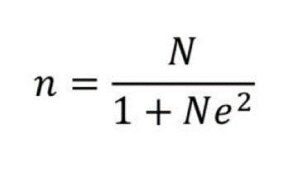

where: n = number of samples

          N = total population

            e = error margin

#### 3.5.4.2. Accuracy

The accuracy in terms of answering of questions in regarding to the chatbot response: